## **Murat Ferhat DERYA-Ahmet Furkan ARIKAN**

#### **by the Countries : Web scraping project**

###### Project start date: 08.12.2024

**Renkler ve Anlamları**

Yeşil :Başarılı bir şekilde veriler çekildi.

Sarı :Veriler Çekilemedi fakat daha gelişmiş tool’lar kullanılır ise bir şansı daha hak ediyor.

Kırmızı :Site herhangi bir şekilde veri çekimine izin vermiyor. Yüksek önlemler alıyor.

1-Canada

AutoTrader.ca: <https://www.autotrader.ca/>

Kijiji Autos: <https://www.kijijiautos.ca/>

3-Europe country

AutoScout24: <https://www.autoscout24.com/>

6-India:

CarDekho: <https://www.cardekho.com/>

Droom: <https://droom.in/>

7-Japan

Car Sensor <https://www.carsensor.net/>

10-United Arab Emirates:

Dubizzle: <https://www.dubizzle.com/>

CarSwitch: [CarSwitch - The Smoothest Way to Buy & Sell Used Cars in the UAE](https://carswitch.com/uae?gad_source=1)

2-United States of America

CarGurus: <https://www.cargurus.co.uk/Cars/spt-used-cars>

eBay Motors: https://www.ebay.com/b/Cars-Trucks/6001/bn_1865117

Craigslist: <https://austin.craigslist.org/search/cta#search=1~gallery~0~0>

Cars: <https://www.cars.com/>

3-Europe country

Mobile.de: <https://www.mobile.de/>

6-India

OLX: <https://www.olx.in/cars_c84>

Cars24: <https://www.cars24.com/>

7-Japan

Goo-net Exchange: <https://www.goo-net-exchange.com/>

8-South Korea

Encar: <https://car.encar.com/>

K Car: <https://www.kcar.com/?srsltid=AfmBOopjAGRdmfHyJkvBvUQvE_H4XqqvqiPfQWXFauut8-VK-nvSpX8n>

10-United Arab Emirates

AutoTrader UAE: <https://www.autotraders.ae/>

11-Egypt:

OLX Egypt: <https://www.dubizzle.com.eg/en/>

7-Japan

Yahoo! Japan Auctions: <https://auctions.yahoo.co.jp/>

8-South Korea

Joonggonara: <https://web.joongna.com/?srsltid=AfmBOooVz-tTonzRfag5lyyWxwHLFhTiE5YUPfNyTTyIJx8H2g9wvOqH>

9-Australia

Carsales: <https://www.carsales.com.au/>

11-Egypt

ContactCars: <https://www.contactcars.com/en>

Hatla2ee: <https://eg.hatla2ee.com/>

12-Brazil

OLX Brazil: <https://www.olx.com.br/>

WebMotors: <https://www.webmotors.com.br/>

4-Russia

Avito: <https://www.avito.ru/>

Kesin olarak engellemis 403 error verdi

Drom.ru: <https://www.drom.ru/>

5-China

58.com: <https://bj.58.com/>

Guazi.com: <https://www.guazi.com/>

Renrenche: <https://m.renrenche.com/bj/car.shtml>

iCarros: <https://www.icarros.com.br/principal/index.jsp>

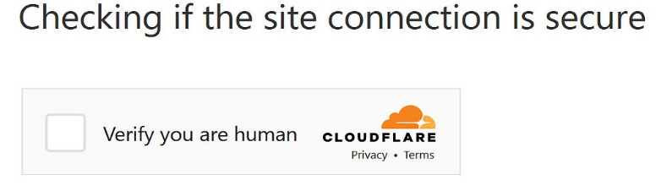

**Note:** Links to the most popular vehicle buying and selling sites used in the countries are given.